DO – DON’T / DOES – DOESN’T

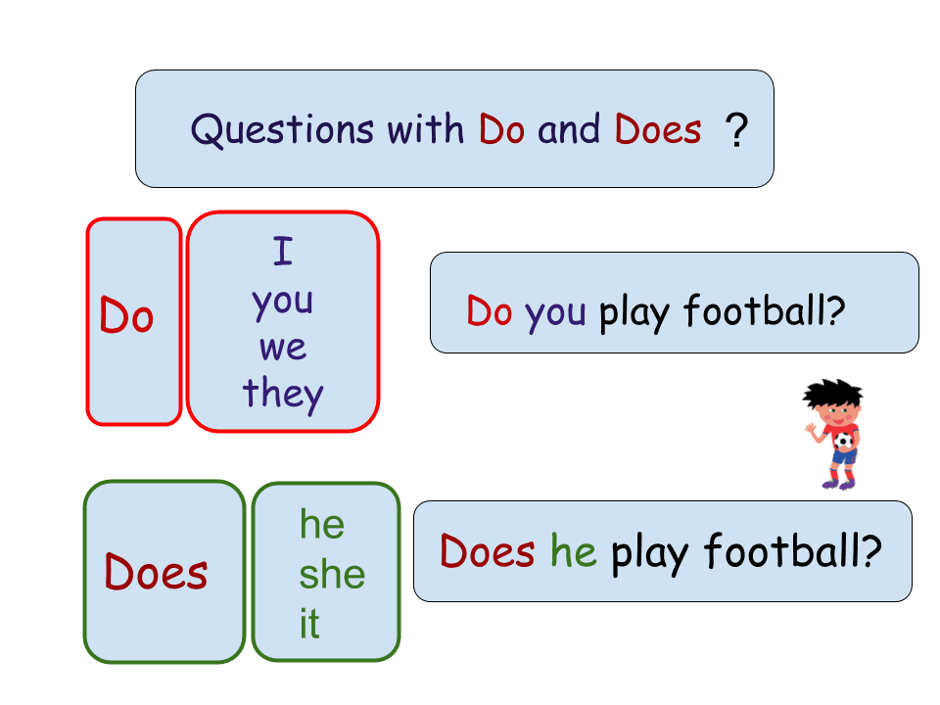
Opdracht 1 Vraagzinnen: vul in do / does
- __________ the teacher work in the weekends?
- __________ you go to parties?
- __________ we drink alcohol?
- __________ they play soccer?
- __________ I like classical ballet?
- __________ the students pay attention?
- __________ Jamira and Yoeri eat lasagne?
- __________ you sleep late?
- __________ Mrs Van Lierop like dark coffee?
- __________ Fine writes with her left hand?

Opdracht 2 Vraagzinnen: vul in do / does en het hele werkwoord
- __________ I __________ a new coat? (need)
- __________ you __________ an ice cream? (want)
- __________ the boy __________ English? (speak)
- __________ the cow __________ very fast? (run)
- __________ my son __________ pizza? (like)
- __________ we __________ Fortnite? (play)
- __________ the dog __________ a lot of noise? (make)
- __________ they __________ to school by bus? (go)
- __________ Mandy __________ in the evening? (study)
- __________ the baby __________ milk? (drink)

Opdracht 3 maak de bijpassende vragen met do / does.
- Didi thinks Mrs Van Lierop is missing.
_____________________________________________________________________
- Their friends take Rens to the restaurant.
_____________________________________________________________________
- Stan buys apples on Saturday.
_____________________________________________________________________
- The dog walks back into the house.
_____________________________________________________________________
- I like to travel.
_____________________________________________________________________
- My sister lives here.
_____________________________________________________________________
- They drink coffee.
_____________________________________________________________________
- Chelsea likes cats.
_____________________________________________________________________
- We cycle a lot.
_____________________________________________________________________
- My father paints the door.
_____________________________________________________________________
- Joran and Jorden worked yesterday at school.
_____________________________________________________________________
- Isa leaves for New York.
_____________________________________________________________________
- He believes Jodi’s story.
_____________________________________________________________________
- You clean your room.
_____________________________________________________________________
- I want to visit you.
_____________________________________________________________________

Opdracht 4 Ontkennende zinnen met do / does.
Voorbeeld: I drink water. I don’t drink water.
- She takes it easy.
_____________________________________________________________________
- I like watermelons.
_____________________________________________________________________
- Your mother wants to come too.
_____________________________________________________________________
- We need a map.
_____________________________________________________________________
- They always talk so loud.
_____________________________________________________________________
- Willem needs help.
_____________________________________________________________________
- You ask a question.
_____________________________________________________________________
- The trains arrives on time.
_____________________________________________________________________
- It rains a lot.
_____________________________________________________________________
- Your parents buy a house.
_____________________________________________________________________
- Esra meets his girlfriend.
_____________________________________________________________________
- I go on a holiday.
_____________________________________________________________________
- Sophie walks to the train station every day.
_____________________________________________________________________
- Lara and her mother shop in London.
_____________________________________________________________________
- The house looks new.
_____________________________________________________________________

